MVP Testing

Testing for User CRUD functionality

/api/User/ListUser

/api/User/Find/{id}

If Id does not exist in table



/api/User/Add

In curl.json

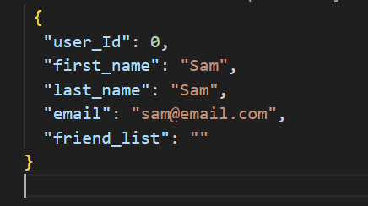



If user input empty string

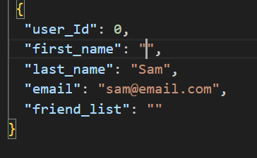

/api/User/Update/{id}

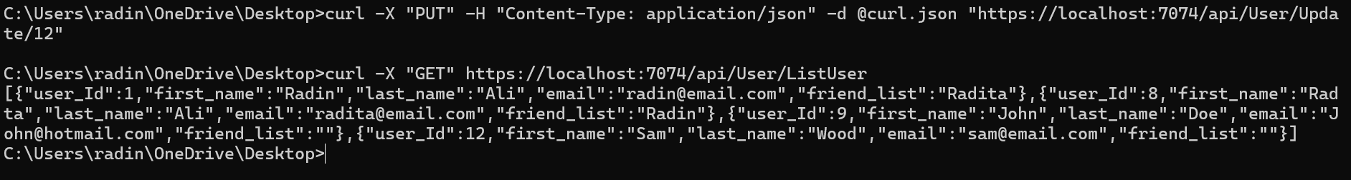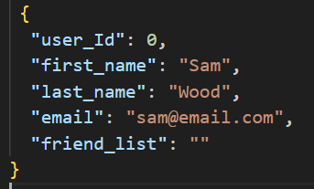

If you try to update with empty field

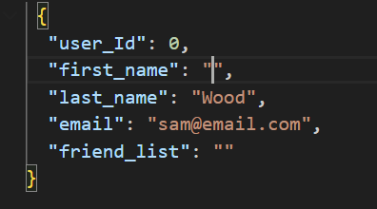

/api/User/Delete/{id}

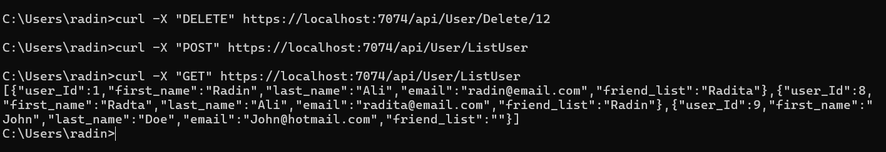Deleting Sam

Deleting someone not from database

Testing for Timeline CRUD functionality

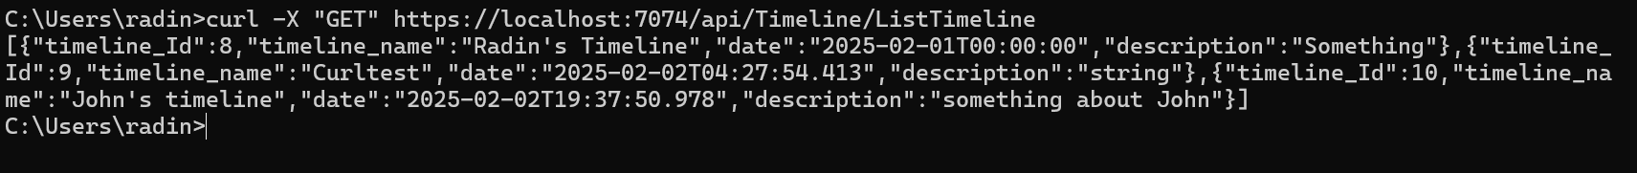/api/Timeline/ListTimeline

/api/Timeline/Find/{id}

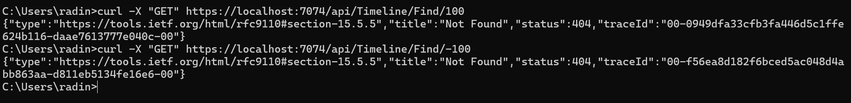Searching for id outside of table

/api/Timeline/Add

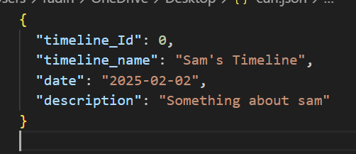

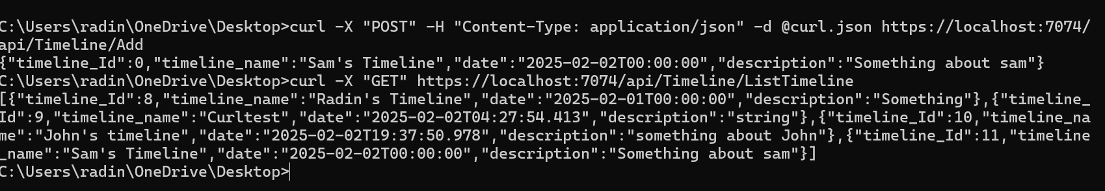

Trying to add with empty field

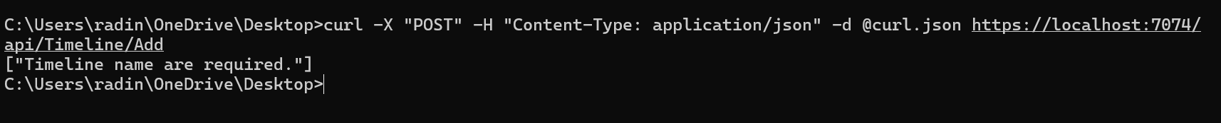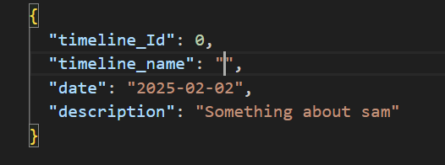

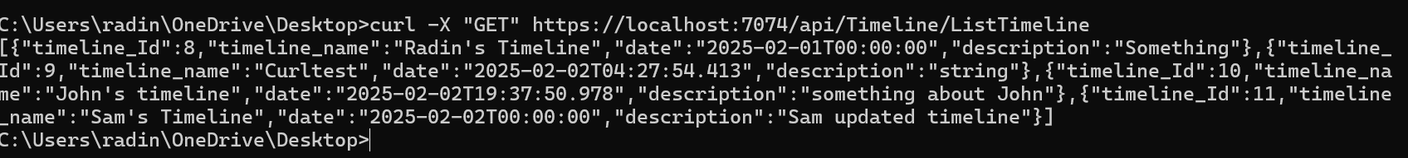/api/Timeline/Update/{id}

Updating with empty field

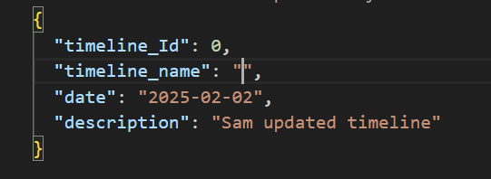



/api/Timeline/Delete/{id}

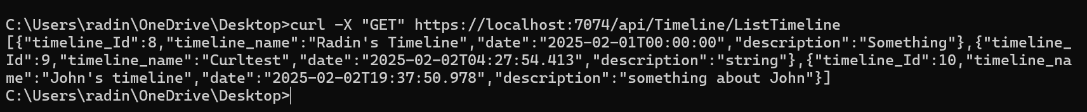

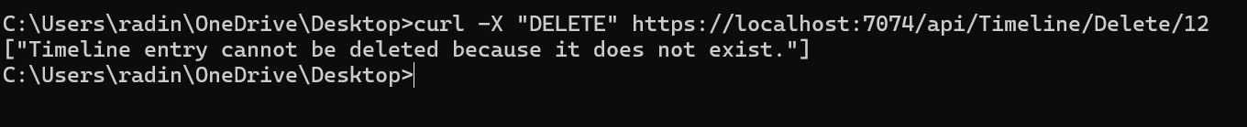Deleting something outside of the table

Testing for Entries CRUD functionality

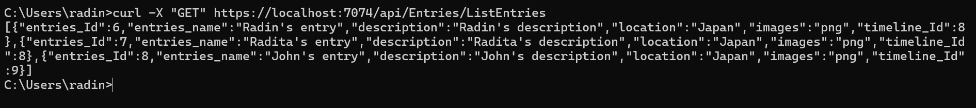/api/Entries/ListEntries

/api/Enties/Find/{id}

/api/Entries/Add

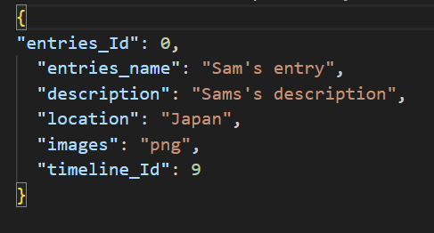

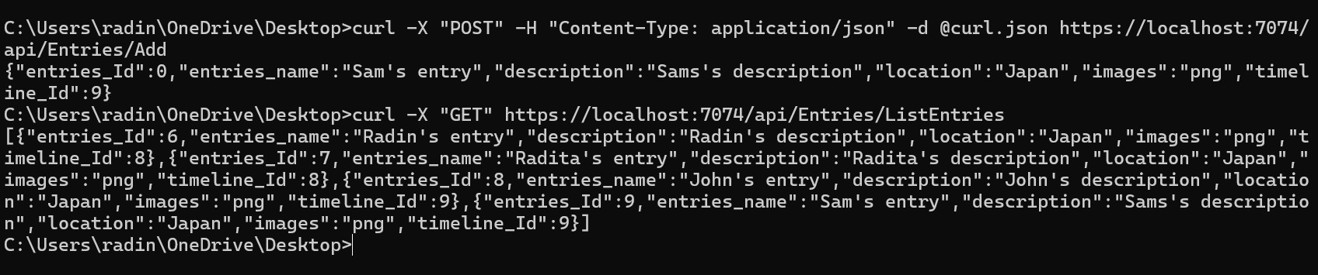

Entering empty field

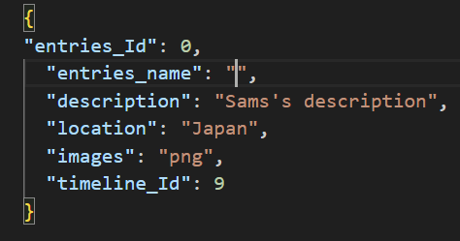



Api/Entries/Update/{id]

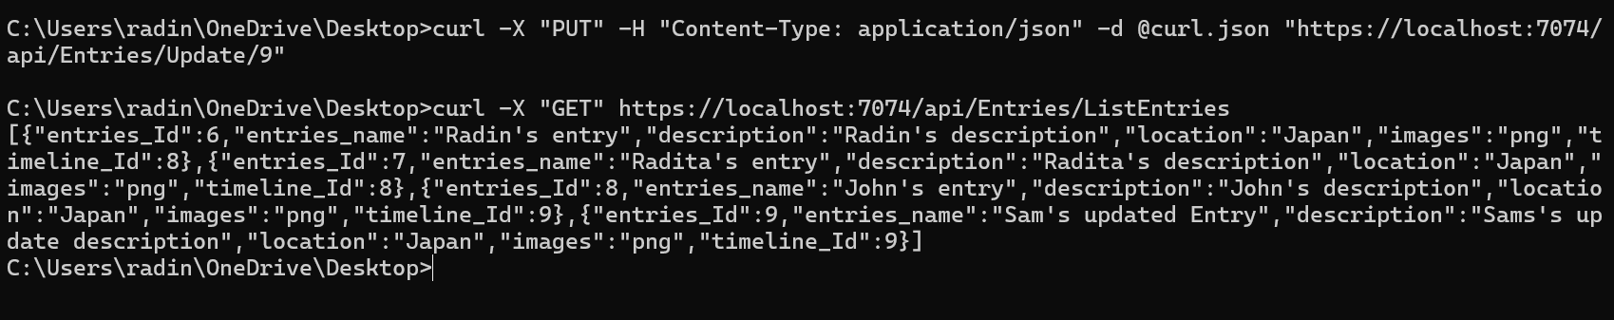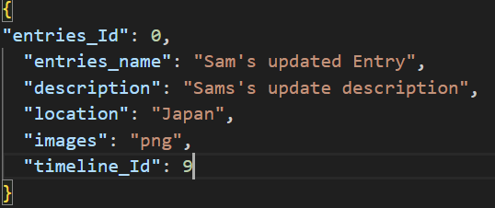

Updating with empty entry

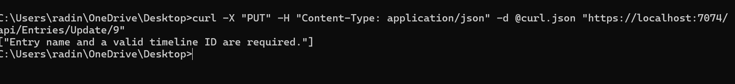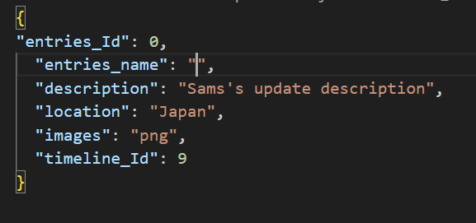

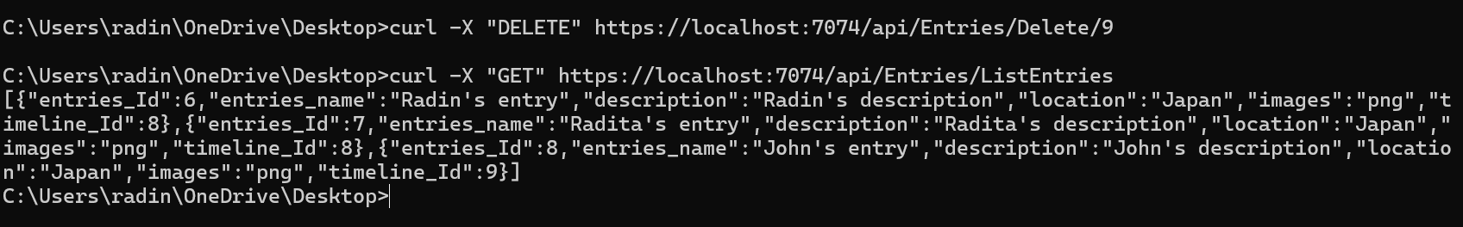/api/Entries/Delete/{id}

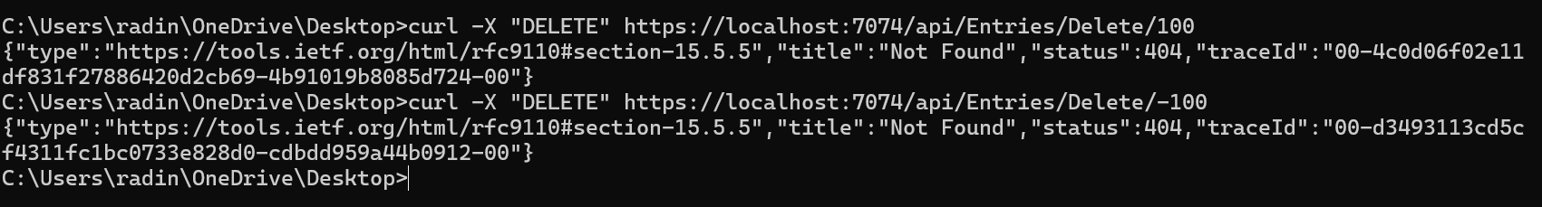Deleting entries outside of table

Testing List functionality of UserTimeline

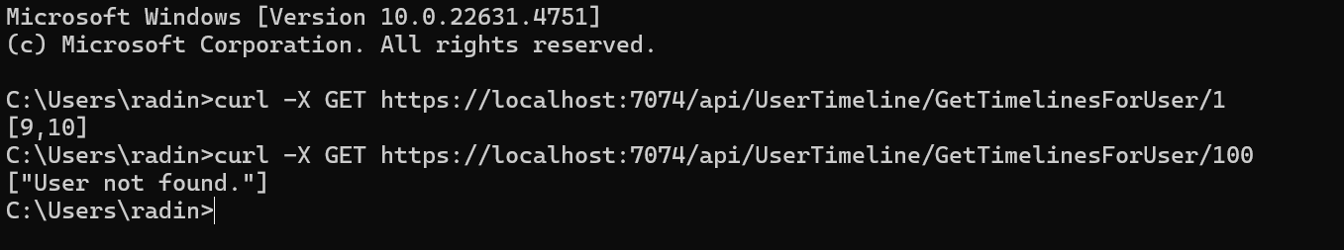/api/UserTimeline/GetTimeLinesForUser/{userId}

/api/UserTimeline/GetUsersForTimeline/{timelineId}

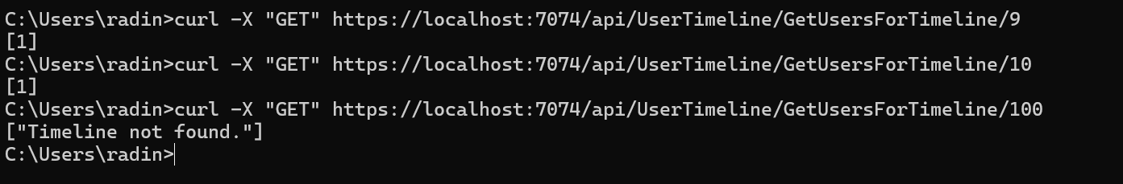

One to many relations between Timeline and Entries

Attempting to add entry to a non-existent timeline

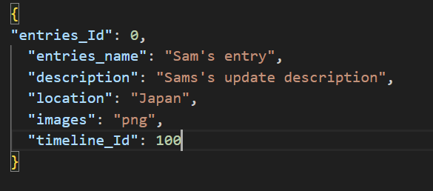

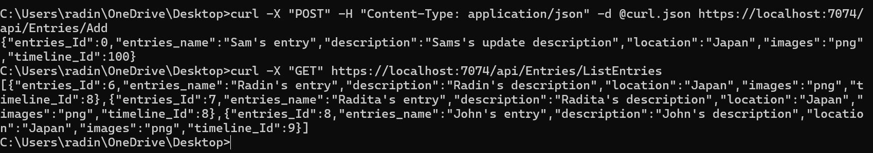

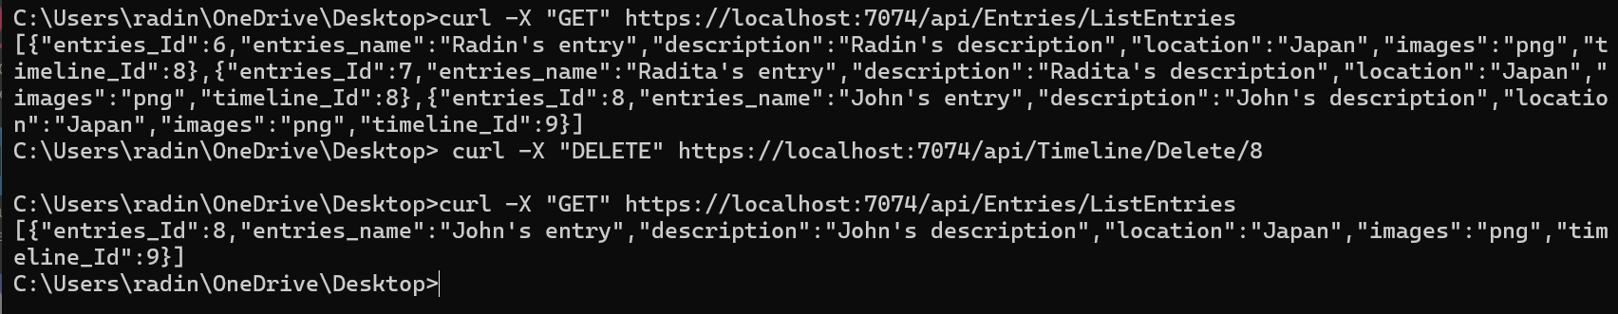Deleting timeline

Many to Many between User and timeline test

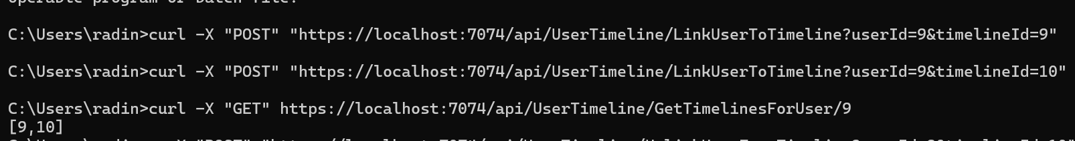/api/UserTimeline/LinkUserToTimeLine

Attempting A user that is already exists in timeline



/api/UserTimeLine/UnlinkUserFromTimeline



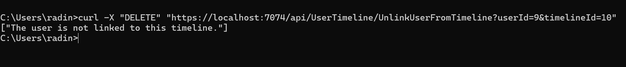Attempting to unlink A user that is not linked to a timeline

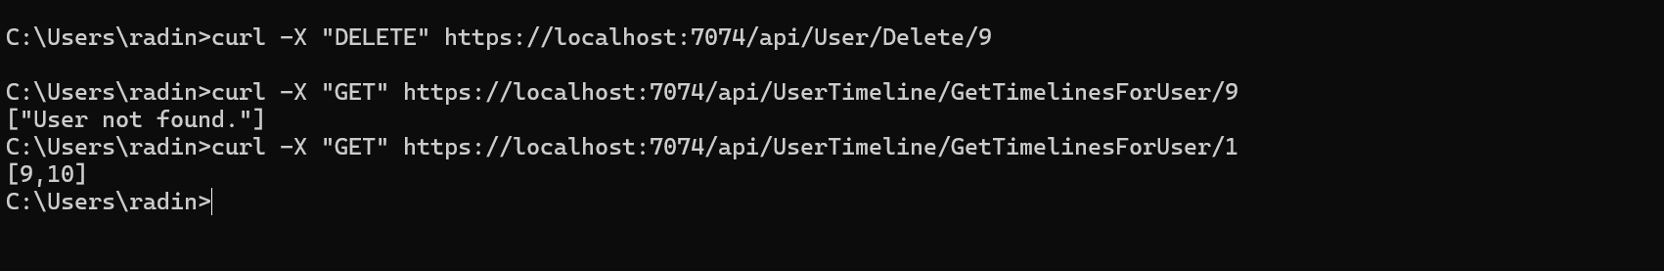Deleting User